CSE 4128: Image Processing and Computer Vision Laboratory
Assignment No:04
Assignment Name: Region Descriptor, Feature Matching and GLCM Texture Analysis

By

Md Rauful Islam Tamim
Roll: 2007009



Department of Computer Science and Engineering
Khulna University of Engineering & Technology
Khulna 9203, Bangladesh
October, 2025
- Lab4 Tasks

1. Take one of each shape as train image and the other as test image.
2. For each binary image:
1. Find the Boundary of the object in the image.
1. Apply erosion to the binary image.
2. Subtract the eroded image from the binary image to get the b border of the region.
2. Calculate Perimeter, Area, Max Diameter of the region.
3.Use Area, Perimeter, and Max Diameter to calculate Form factor, R o Roundness, and Compactness and save it in a txt file.
3. Matching the descriptors of the test and train images to find close Match.

Lab Tasks Output:

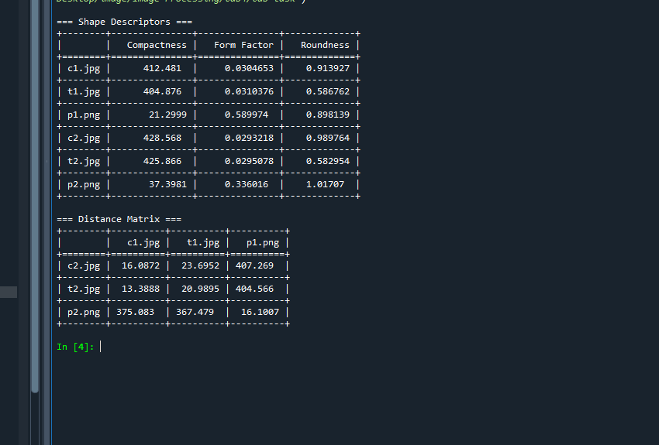

Figure 1: Shape Descriptors and Distance Matrix

- Assignment 1

1.Take a gray scale input image and Calculate the
i) Diagonal, Vertical and horizontal GLCM matrices and visualize them. (ii) For each of the 3 GLCM matrices find the 5 texture features
a) Maximum probability
b) Energy
c) Entropy
d) Contrast
e) Homogeneity

2. Take a small 5x5 image patch from any of your input image. Apply the above mention operations and demonstrate in your report

Solutions
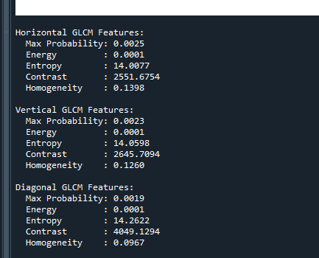
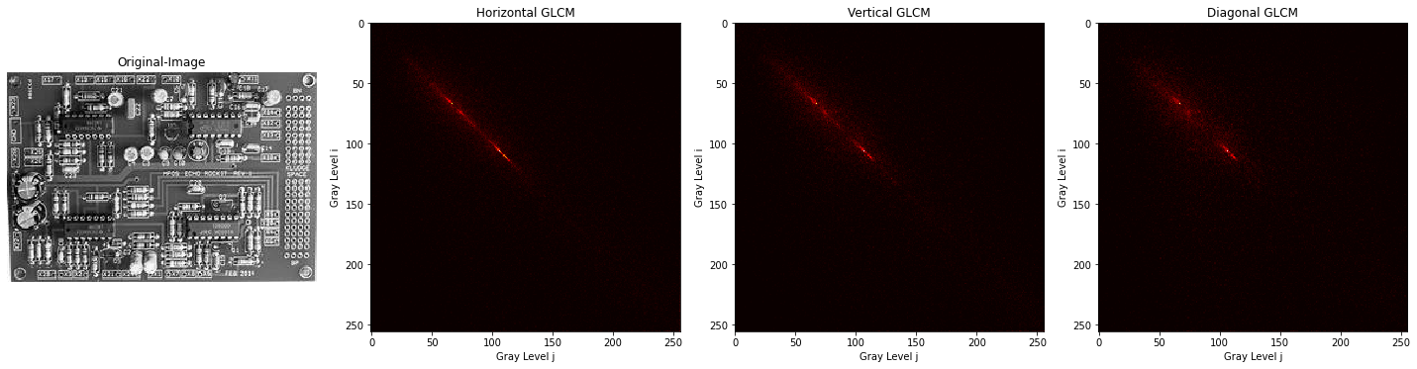
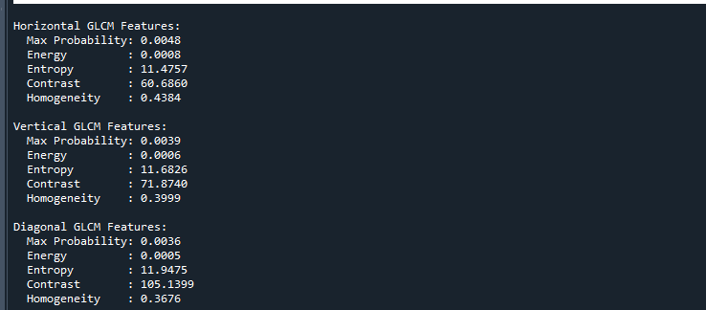

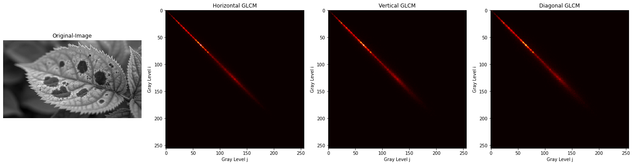

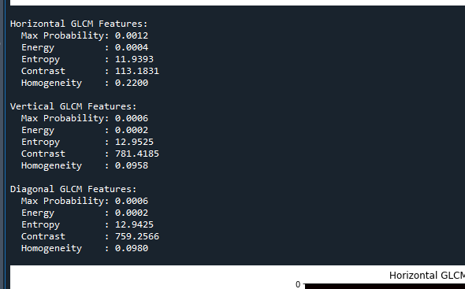

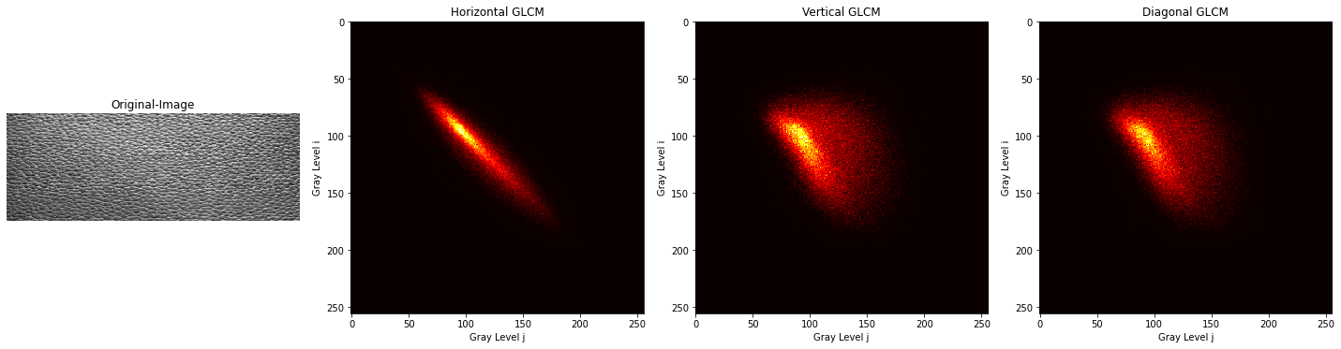

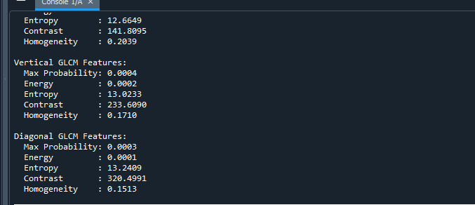

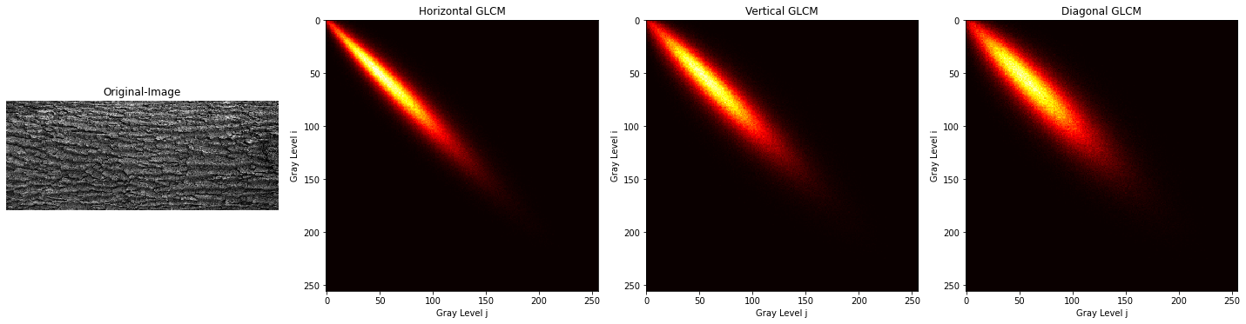

Assignment 2

2. Take a small 5x5 image patch from any of your input image. Apply the above mention operations and demonstrate in your report

